Create a civilization of your very own by choosing the resources you think will be the most useful. As you choose your resources, consider what will make your civilization successful. After choosing your resources, you will draw a map of your civilization (on the back of this paper) that will be displayed in the classroom.

My civilization is called _________________________________________

**Section 1:** My civilization is located… (circle **one**)

* 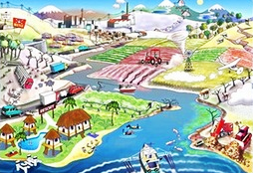next to an ocean
* in the mountains
* on an island
* in the rainforest
* next to a river
* in the desert

**Section 2:** My civilization raises… (circle **two**)

* 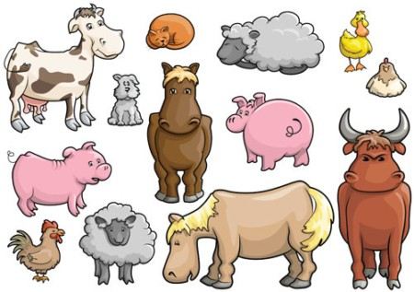horses
* chickens
* camels
* llamas
* cows
* cats
* dogs
* fish

**Section 3:** My civilization grows… (circle **two**)

* corn
* 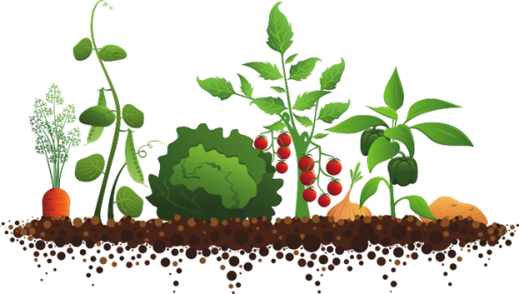wheat
* potatoes
* beans
* oranges
* pine trees
* roses

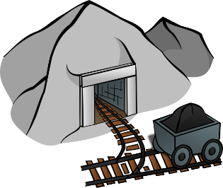**Section 4:** My civilization also has… (pick **two**)

* gold
* iron
* stone
* silk
* bronze

Name:

|  |  |  |
| --- | --- | --- |
| KEY | | |
| Symbol | Section | Choice |
|  | (2) My civilization raises… |  |
|  | (2) My civilization raises… |  |
|  | (3) My civilization grows… |  |
|  | (3) My civilization grows… |  |
|  | (4) My civilization also has… |  |
|  | (4) My civilization also has… |  |